Assignment -4

|  |  |
| --- | --- |
| Assignment Date | 14 November 2022 |
| Student Name | ATHIVIGNESHKUMAR N |
| Student Roll Number | 953619104006 |
| Maximum Marks | 2 Marks |

1. **Pull an Image from docker hub and run it in docker playground**

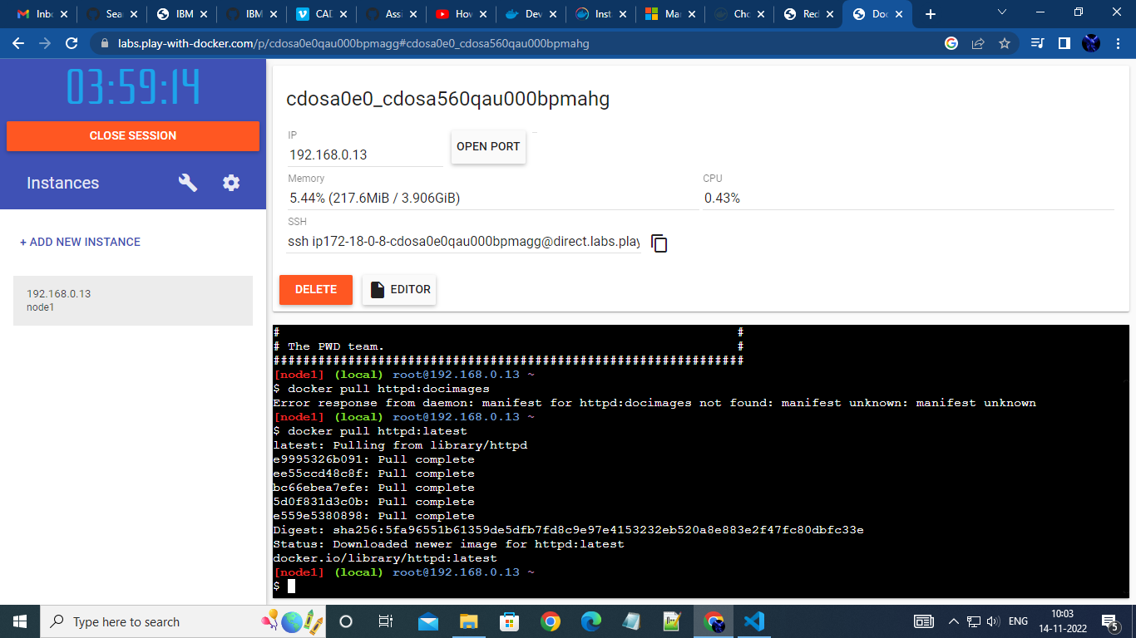

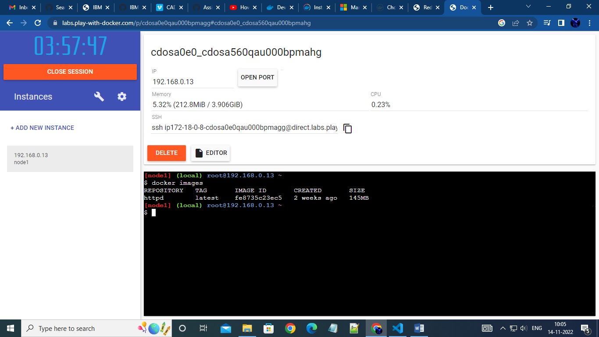

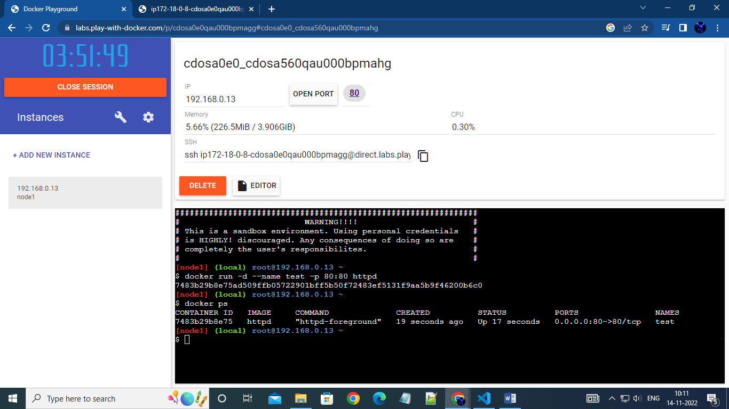

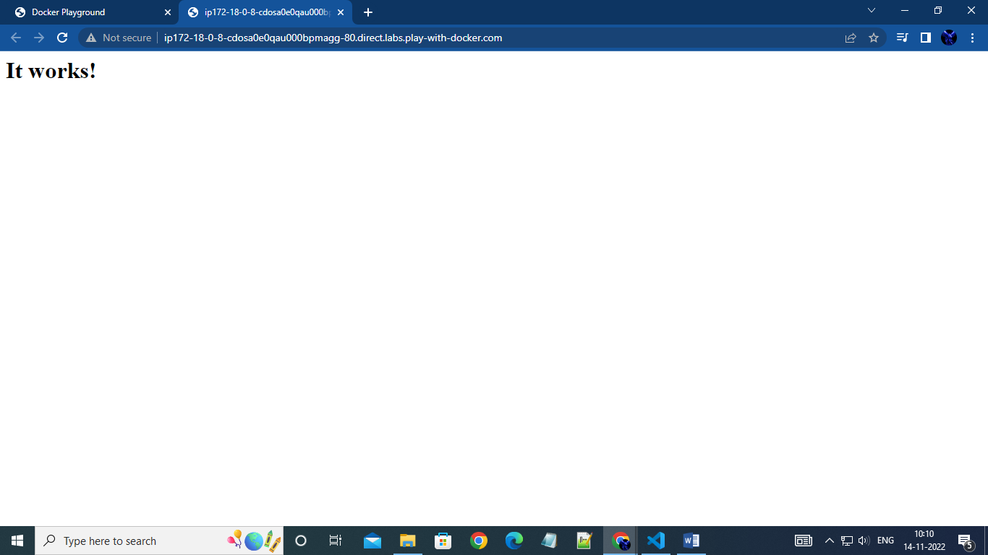

1. **Create a docker file for the jobportal application and deploy it in Docker desktop application.**

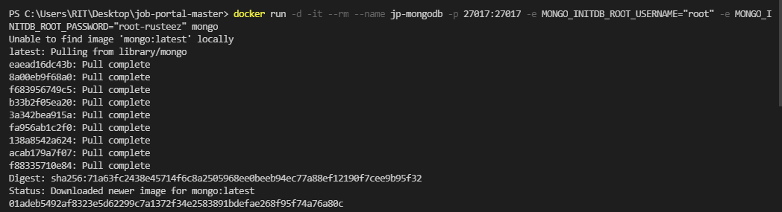

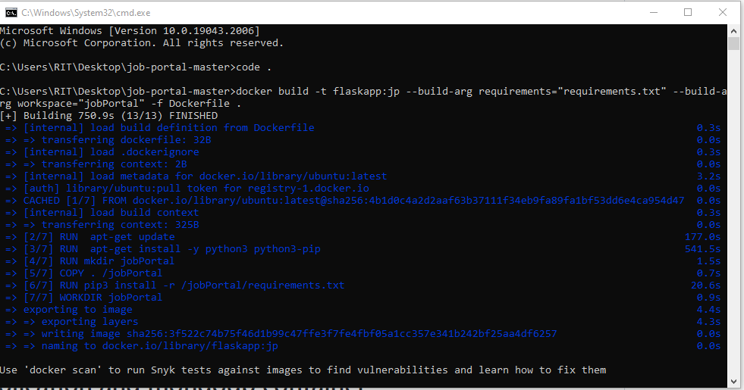



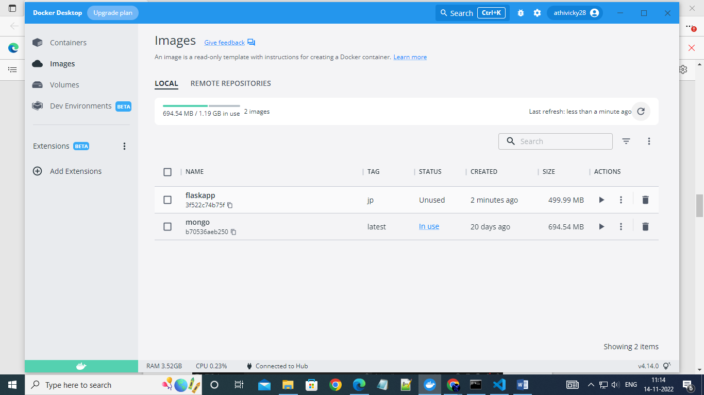

3.Create a IBM container registry and deploy helloworld app or jobportalapp.

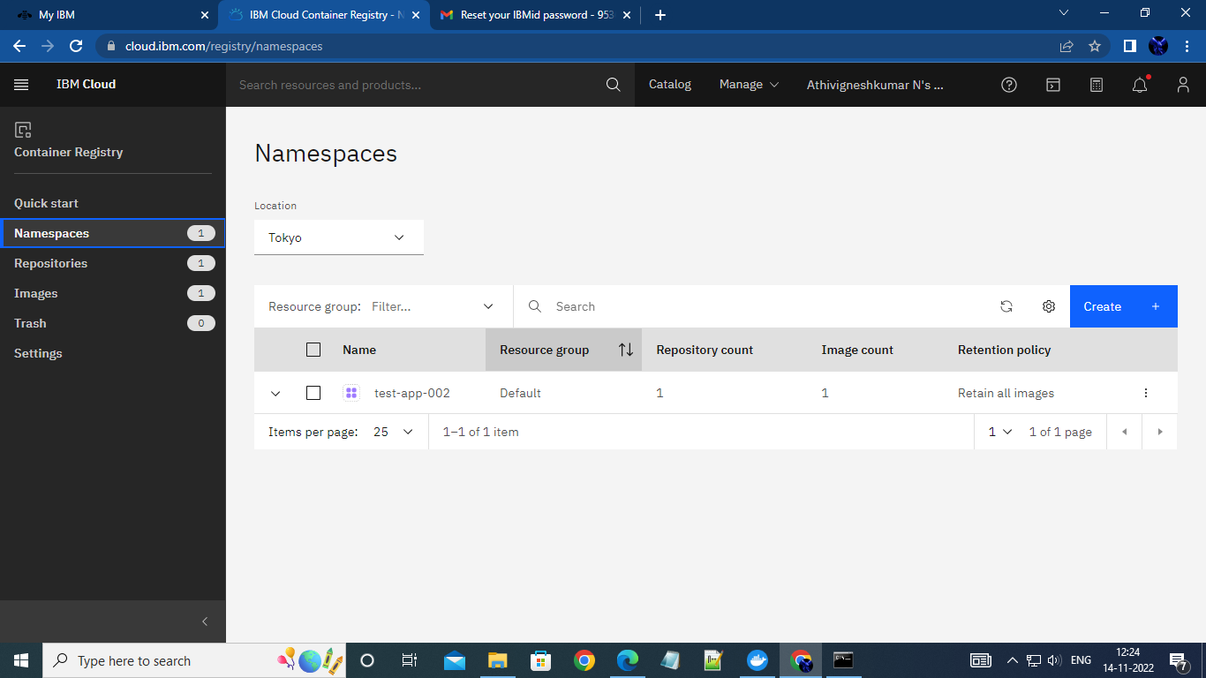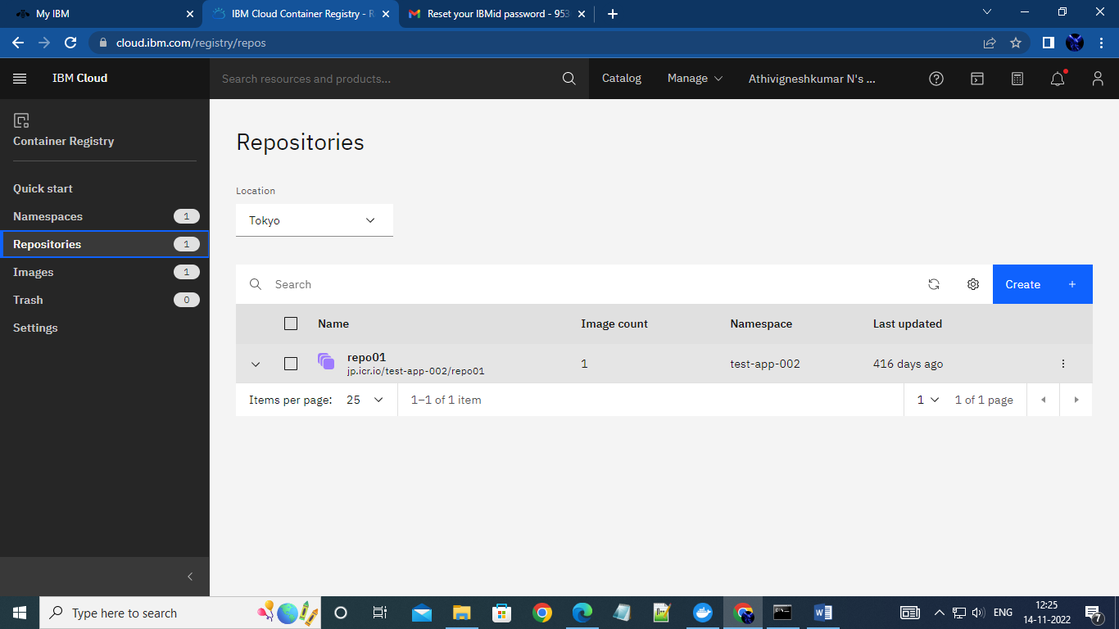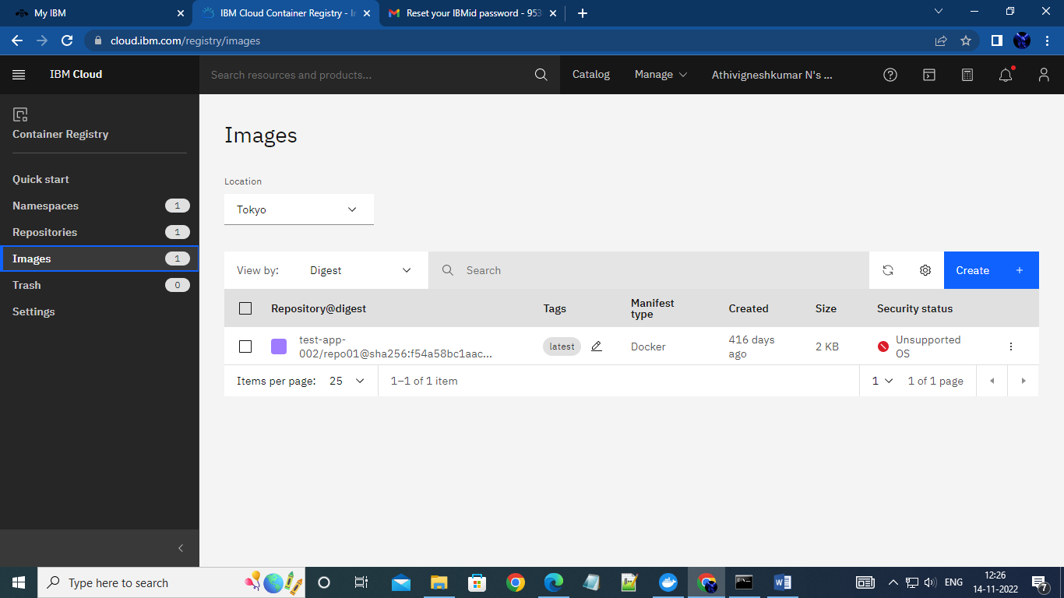

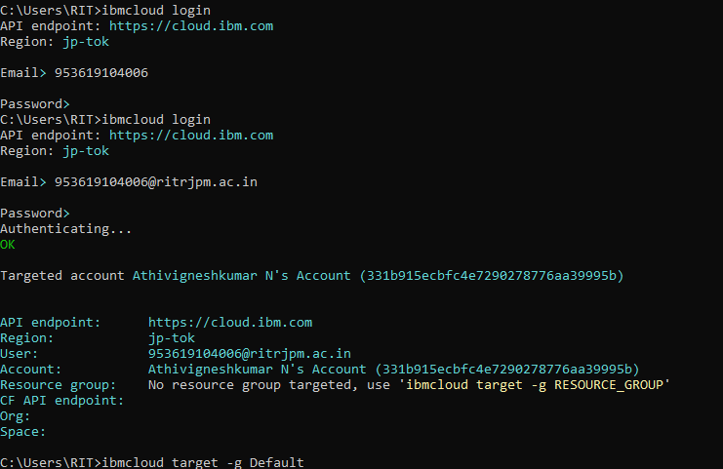

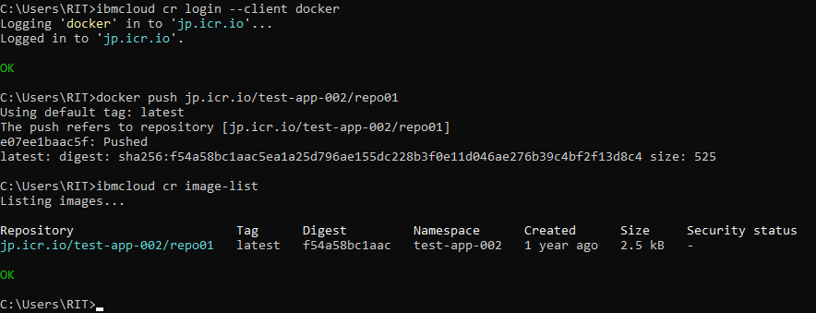

4.Create a Kubernetes cluster in IBM cloud and deploy helloworld image or jobportal image and also expose the same app to run in nodepor

